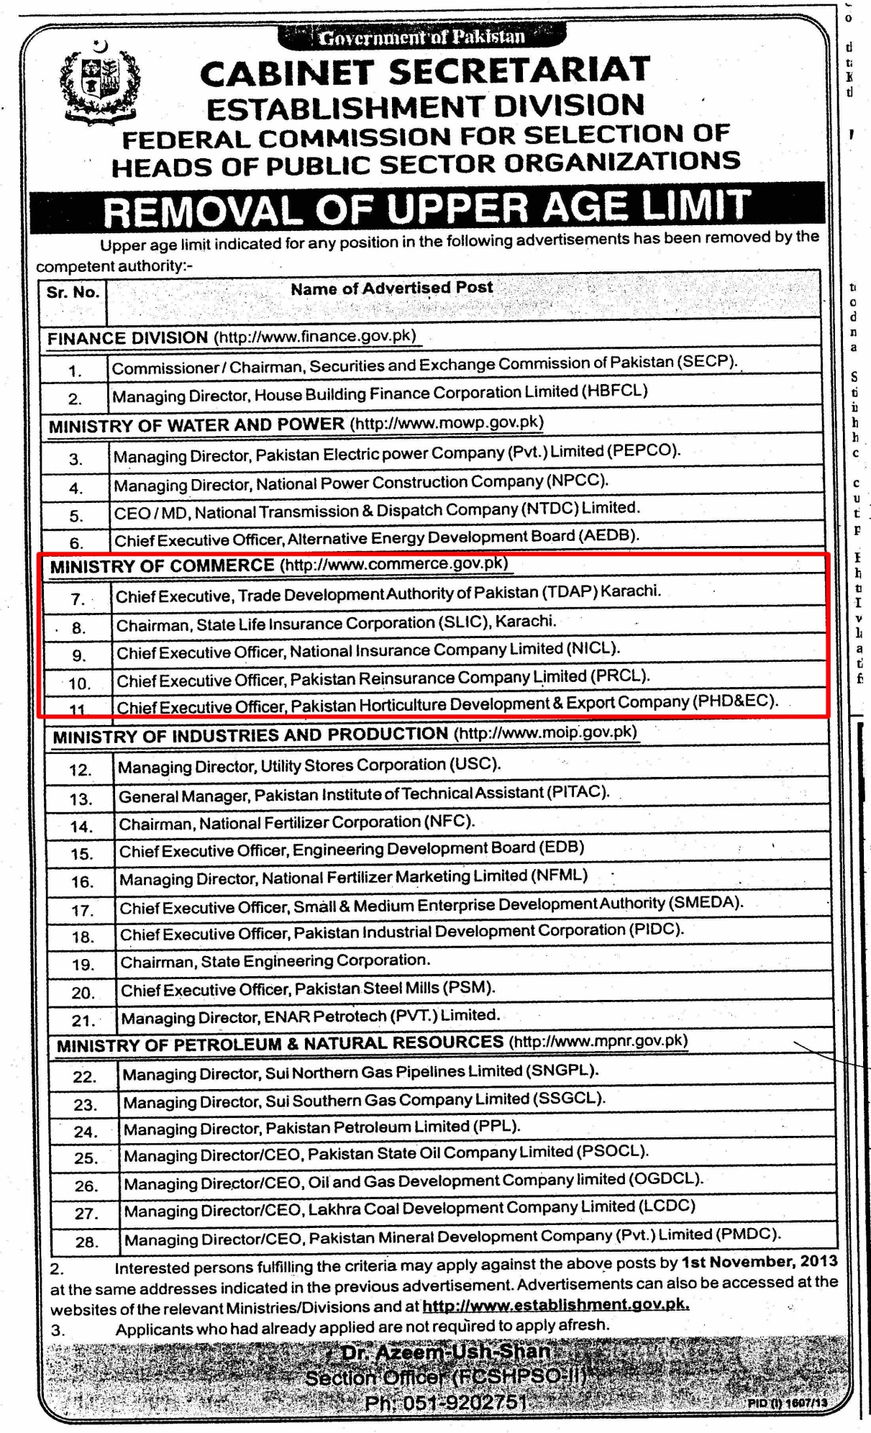
APPLICATION FORM
1. | PERSONAL
a | Name: (former name if any):
b. | Father’s or Husband Name:
c. | C.N.I.C # (attach copy)
d. | Nationality :
e. | Age:
f. | Contact Details
 | i)Residential Address:
 | ii) Business Address:
 | iii) Tel:
 | iv) Mobile:
 | v) Fax:
 | vi)E-mail
g. | National Tax Number:
h. | Present Occupation:
I. | Qualification(s):
 | i) Academic:
 | S.No. Name of Institution Duration Degree / Diploma % Marks Obtained
ii)Professional:
S.No. | Name of Institution | Duration | Degree / Diploma

2. | WORK EXPERIENCE:  (Positions held since the first professional assignment in descending order )
 | S. No. Organization Duration Job Responsibilities Major Achievements reflecting qualifications / abilities matching to the post Reasons for leaving
3. | Nature of directorship Executive Non-executive  Status of directorship Nominee director  Number of shares subscribed or held:  Nominated by (Name of Shareholder):  Personal Net Worth(Copy of Wealth Statement):
4. | Names of companies, firms and other organizations of which the proposed person is a director, partner, office holder.
5. | Names of persons on the board of the Pakistan Horticulture Development Export Company (PHDEC) who are related to the applicant. (If any)
6. | What are the current issues and challenges in the Horticulture Sector of Pakistan and how can PHDEC develop the supply chain to enhance Pakistan’s horticulture exports. (Write 700 to 800 words)
7. | What makes the applicant the most suitable candidate for the position of CEO PHDEC? (Write 400 to 500 words)

I UNDERTAKE THAT I FULLFILL THE CRITERIA OF FIT AND PROPER AS DEFINED IN THE PUBLIC SECTOR COMPANIES (CORPORATE GOVERNANCE) RULES, 2013.

Signature:
Dated:

Kindly attach the following documents in support of your application.
- Application for the post.
- Detailed CV / Resume containing all the relevant details regarding the academic and professional experience of the applicant.
- Copies of ID Card, National Tax Number (NTN), academic transcripts / degrees and testimonials from former employers attested by a gazetted officer
- Three latest passport size pictures.
- An affidavit to the effect that the candidate is not having dual nationality, duly verified by Magistrate Class-I.
- Please use additional sheets where necessary.

